2.

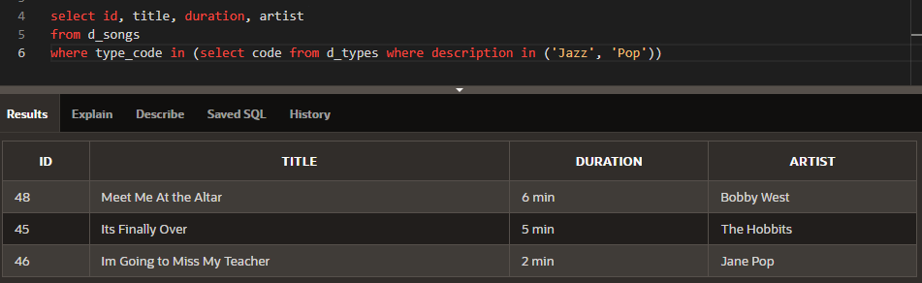

3.

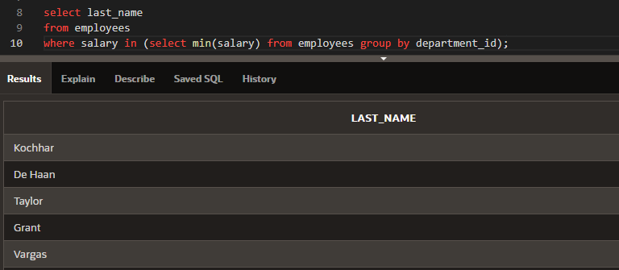

4.

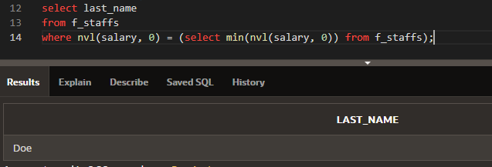

5.

a. <

b. < any

c. in

d. > all

6.

__T__a. WHERE size > ANY -- If the inner query returns sizes ranging from 8 to 12, the value 9 could be returned in the outer query.

__F __b. WHERE book_number IN -- If the inner query returns books numbered 102, 105, 437, and 225 then 325 could be returned in the outer query.

__F__c. WHERE score <= ALL -- If the inner query returns the scores 89, 98, 65, and 72, then 82 could be returned in the outer query.

__T__d. WHERE color NOT IN -- If the inner query returns red, green, blue, black, and then the outer query could return white.

__F__e. WHERE game_date = ANY -- If the inner query returns 05-Jun-1997, 10-Dec-2002, and 2-Jan-2004, then the outer query could return 10-Sep-2002.

7.

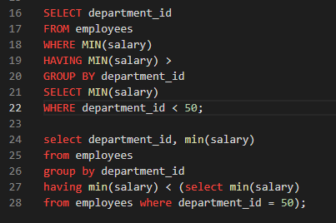

8.

SELECT employee_id, last_name

FROM employees

WHERE salary =

(SELECT MIN(salary)

FROM employees

GROUP BY department_id);

___F___ a. The inner query could be eliminated simply by changing the WHERE clause to WHERE MIN(salary).

___T___ b. The query wants the names of employees who make the same salary as the smallest salary in any department.

___F___ c. The query first selects the employee ID and last name, and then compares that to the salaries in every department.

___T___ d. This query will not execute.

9.

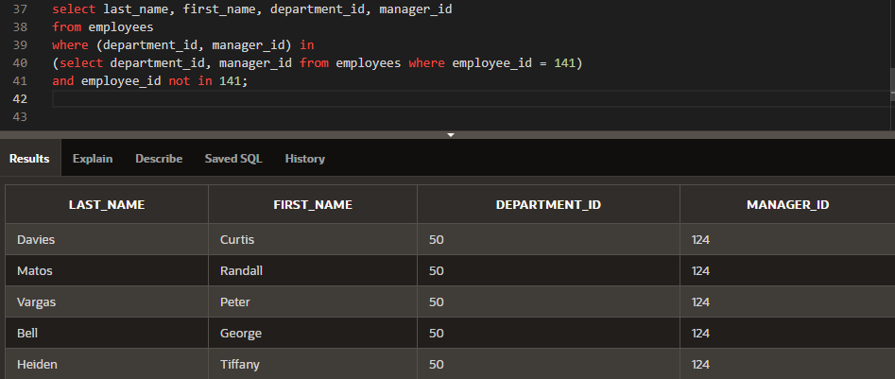

10.

